Week 2

Activities and Intents

Application Name: Two Activities

Activity_main.xml

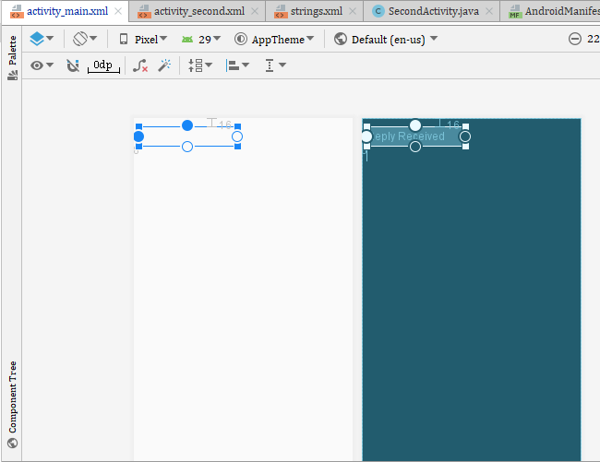

|  |
| --- |
| <TextView  android:id="@+id/text_header_reply"  android:layout_width="186dp"  android:layout_height="36dp"  android:layout_marginStart="8dp"  android:layout_marginTop="16dp"  android:background="#00332727"  android:text="@string/text_header_reply"  android:textAppearance="@style/TextAppearance.AppCompat.Medium"  android:textColorLink="#001A1919"  android:textSize="24sp"  android:textStyle="bold"  android:visibility="invisible"  app:layout_constraintStart_toStartOf="parent"  app:layout_constraintTop_toTopOf="parent" /> <TextView  android:id="@+id/text_message_reply"  android:layout_width="wrap_content"  android:layout_height="wrap_content"  android:layout_marginStart="8dp"  android:layout_marginLeft="8dp"  android:layout_marginTop="8dp"  android:visibility="invisible"  app:layout_constraintStart_toStartOf="parent"  app:layout_constraintTop_toBottomOf="@+id/text_header_reply" />   <Button  android:id="@+id/button_main"  android:layout_width="wrap_content"  android:layout_height="wrap_content"  android:layout_marginBottom="16dp"  android:layout_marginRight="16dp"  android:text="@string/button_main"  android:onClick="launchSecondActivity"  app:layout_constraintBottom_toBottomOf="parent"  app:layout_constraintRight_toRightOf="parent" />  <EditText  android:id="@+id/editText_main"  android:layout_width="0dp"  android:layout_height="wrap_content"  android:layout_marginBottom="16dp"  android:layout_marginEnd="8dp"  android:layout_marginStart="8dp"  android:ems="10"  android:hint="@string/editText_main"  android:inputType="textLongMessage"  app:layout_constraintBottom_toBottomOf="parent"  app:layout_constraintEnd_toStartOf="@+id/button_main"  app:layout_constraintStart_toStartOf="parent" /> |

Activity_second.xml

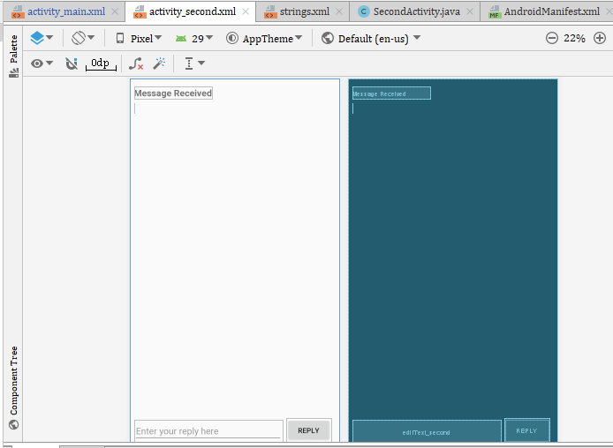

Codes

|  |
| --- |
| <**TextView android:id="@+id/text_header" android:layout_width="wrap_content" android:layout_height="wrap_content" android:layout_marginStart="8dp" android:layout_marginLeft="8dp" android:layout_marginTop="16dp" android:text="@string/text_header" android:textAppearance=  "@style/TextAppearance.AppCompat.Medium" android:textStyle="bold" app:layout_constraintStart_toStartOf="parent" app:layout_constraintTop_toTopOf="parent"** /> <**TextView  android:id="@+id/text_message"  android:layout_width="wrap_content"  android:layout_height="wrap_content"  android:layout_marginStart="8dp"  android:layout_marginTop="8dp"  app:layout_constraintStart_toStartOf="parent"  app:layout_constraintTop_toBottomOf="@+id/text_header"** />   <**Button  android:id="@+id/button_second"  android:layout_width="wrap_content"  android:layout_height="wrap_content"  android:layout_marginBottom="16dp"  android:layout_marginRight="16dp"  android:text="@string/button_second"  android:onClick="returnReply"  app:layout_constraintBottom_toBottomOf="parent"  app:layout_constraintRight_toRightOf="parent"** />  <**EditText  android:id="@+id/editText_second"  android:layout_width="0dp"  android:layout_height="wrap_content"  android:layout_marginBottom="16dp"  android:layout_marginEnd="8dp"  android:layout_marginStart="8dp"  android:ems="10"  android:hint="@string/editText_second"  android:inputType="textLongMessage"  app:layout_constraintBottom_toBottomOf="parent"  app:layout_constraintEnd_toStartOf="@+id/button_second"  app:layout_constraintStart_toStartOf="parent"** /> |

SecondActivity.Java

|  |
| --- |
| **package** com.example.twoactivities;  **import** androidx.annotation.Nullable; **import** androidx.appcompat.app.AppCompatActivity;  **import** android.content.Intent; **import** android.os.Bundle; **import** android.util.Log; **import** android.view.View; **import** android.widget.EditText; **import** android.widget.TextView;  **public class** SecondActivity **extends** AppCompatActivity {  **private** EditText **mReply**;  **public static final** String ***EXTRA_REPLY*** =  **"com.example.android.twoactivities.extra.REPLY"**;  **private static final** String ***LOG_TAG*** = SecondActivity.**class**.getSimpleName();   @Override  **protected void** onStart() {  **super**.onStart();  Log.*d*(***LOG_TAG***, **"onStart"**);  }   @Override  **protected void** onPause() {  **super**.onPause();  Log.*d*(***LOG_TAG***, **"onPause"**);  }   @Override  **protected void** onRestart() {  **super**.onRestart();  Log.*d*(***LOG_TAG***, **"onRestart"**);  }   @Override  **protected void** onResume() {  **super**.onResume();  Log.*d*(***LOG_TAG***, **"onResume"**);  }   @Override  **protected void** onStop() {  **super**.onStop();  Log.*d*(***LOG_TAG***, **"onStop"**);  }   @Override  **protected void** onDestroy() {  **super**.onDestroy();  Log.*d*(***LOG_TAG***, **"onDestroy"**);  }  **protected void** onCreate(Bundle savedInstanceState) {  **super**.onCreate(savedInstanceState);  setContentView(R.layout.***activity_second***);  Intent intent = getIntent();  String message = intent.getStringExtra(MainActivity.***EXTRA_MESSAGE***);  TextView textView = findViewById(R.id.***text_message***);  textView.setText(message);  **mReply** = findViewById(R.id.***editText_second***);  }   **public void** returnReply(View view) {  String reply = **mReply**.getText().toString();  Intent replyIntent = **new** Intent();  replyIntent.putExtra(***EXTRA_REPLY***, reply);  setResult(***RESULT_OK***, replyIntent);  Log.*d*(***LOG_TAG***, **"End SecondActivity"**);  finish();  }    } |

MainActivity.Java

|  |
| --- |
| **package** com.example.twoactivities;  **import** androidx.annotation.Nullable; **import** androidx.appcompat.app.AppCompatActivity;  **import** android.content.Intent; **import** android.os.Bundle; **import** android.util.Log; **import** android.view.View; **import** android.widget.EditText; **import** android.widget.TextView;   **public class** MainActivity **extends** AppCompatActivity {  **private static final** String ***LOG_TAG*** = MainActivity.**class**.getSimpleName();  **public static final** String ***EXTRA_MESSAGE*** =  **"com.example.android.twoactivities.extra.MESSAGE"**;  **private** EditText **mMessageEditText**;  **public static final int *TEXT_REQUEST*** = 1;  **private** TextView **mReplyHeadTextView**;  **private** TextView **mReplyTextView**;    @Override  **public void** onStart(){  **super**.onStart();  Log.*d*(***LOG_TAG***, **"onCreate"**);  Log.*d*(***LOG_TAG***, **"onStart"**);  Log.*d*(***LOG_TAG***, **"-------"**);  Log.*d*(***LOG_TAG***, **"onResume"**);  }  @Override  **public void** onSaveInstanceState(Bundle outState) {  **super**.onSaveInstanceState(outState);  **if** (**mReplyHeadTextView**.getVisibility() == View.***VISIBLE***) {  outState.putBoolean(**"reply_visible"**, **true**);  }  outState.putString(**"reply_text"**,**mReplyTextView**.getText().toString());  }  **protected void** onCreate(Bundle savedInstanceState) {  **super**.onCreate(savedInstanceState);  setContentView(R.layout.***activity_main***);  Log.*d*(***LOG_TAG***, **"-------"**);  Log.*d*(***LOG_TAG***, **"onCreate"**);  **mMessageEditText** = findViewById(R.id.***editText_main***);  **mReplyHeadTextView** = findViewById(R.id.***text_header_reply***);  **mReplyTextView** = findViewById(R.id.***text_message_reply***);  **if** (savedInstanceState != **null**) {  **boolean** isVisible = savedInstanceState.getBoolean(**"reply_visible"**);  **if** (isVisible) {  **mReplyHeadTextView**.setVisibility(View.***VISIBLE***);  **mReplyTextView**.setText(savedInstanceState.getString(**"reply_text"**));  **mReplyTextView**.setVisibility(View.***VISIBLE***);  }   }   }   @Override  **protected void** onPause() {  **super**.onPause();  Log.*d*(***LOG_TAG***, **"onPause"**);  }   @Override  **protected void** onRestart() {  **super**.onRestart();  Log.*d*(***LOG_TAG***, **"onRestart"**);  }   @Override  **protected void** onResume() {  **super**.onResume();  Log.*d*(***LOG_TAG***, **"onResume"**);  }   @Override  **protected void** onStop() {  **super**.onStop();  Log.*d*(***LOG_TAG***, **"onStop"**);  }   @Override  **protected void** onDestroy() {  **super**.onDestroy();  Log.*d*(***LOG_TAG***, **"onDestroy"**);  }   **public void** launchSecondActivity(View view) {  Log.*d*(***LOG_TAG***, **"Button clicked!"**);  Intent intent = **new** Intent(**this**, SecondActivity.**class**);  String message = **mMessageEditText**.getText().toString();  intent.putExtra(***EXTRA_MESSAGE***, message);  startActivity(intent);  startActivityForResult(intent, ***TEXT_REQUEST***);  }   @Override  **protected void** onActivityResult(**int** requestCode, **int** resultCode, @Nullable Intent data) {  **super**.onActivityResult(requestCode, resultCode, data);  **if** (requestCode == ***TEXT_REQUEST***) {  **if** (resultCode == ***RESULT_OK***) {  String reply =  data.getStringExtra(SecondActivity.***EXTRA_REPLY***);  **mReplyHeadTextView**.setVisibility(View.***VISIBLE***);  **mReplyTextView**.setText(reply);  **mReplyTextView**.setVisibility(View.***VISIBLE***);  }  }  } } |

AndroidManifest.xml

|  |
| --- |
| *<?***xml version="1.0" encoding="utf-8"***?>* <**manifest xmlns:android="http://schemas.android.com/apk/res/android"  package="com.example.twoactivities"**>   <**application  android:allowBackup="true"  android:icon="@mipmap/ic_launcher"  android:label="@string/app_name"  android:roundIcon="@mipmap/ic_launcher_round"  android:supportsRtl="true"  android:theme="@style/AppTheme"**>   <**activity android:name=".MainActivity"**>  <**intent-filter**>  <**action android:name="android.intent.action.MAIN"** />   <**category android:name="android.intent.category.LAUNCHER"** />  </**intent-filter**>  </**activity**>  <**activity android:name=".SecondActivity"  android:label = "Second Activity"  android:parentActivityName=".MainActivity"**>  <**meta-data  android:name="android.support.PARENT_ACTIVITY"  android:value=  "com.example.twoactivities.MainActivity"** />  </**activity**>  </**application**>  </**manifest**> |

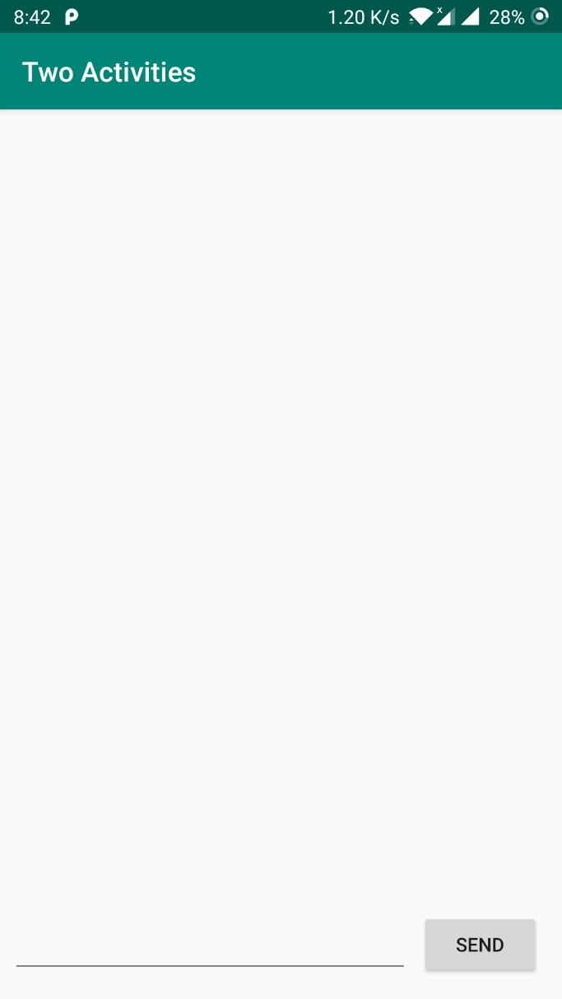 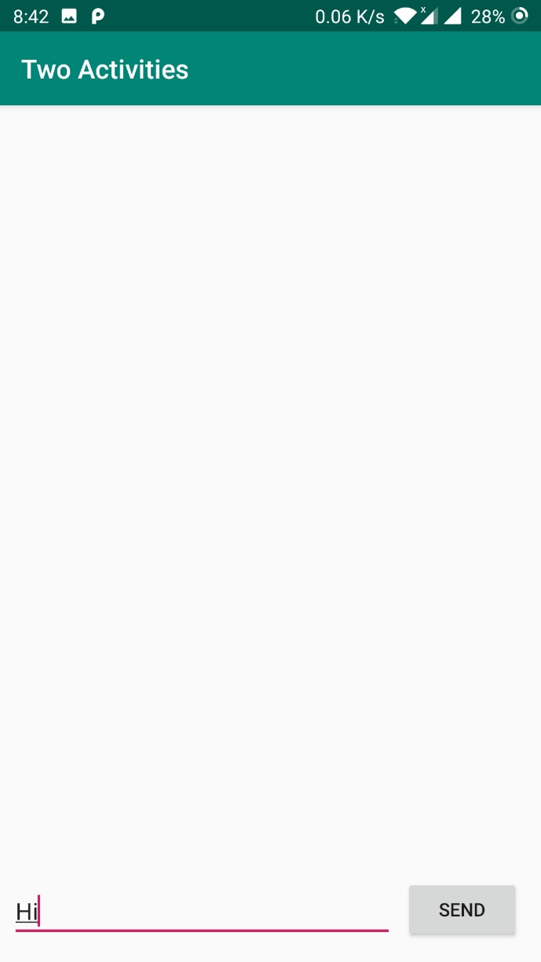

The clicking of send button results the sending the Hi message from main activity to second activity

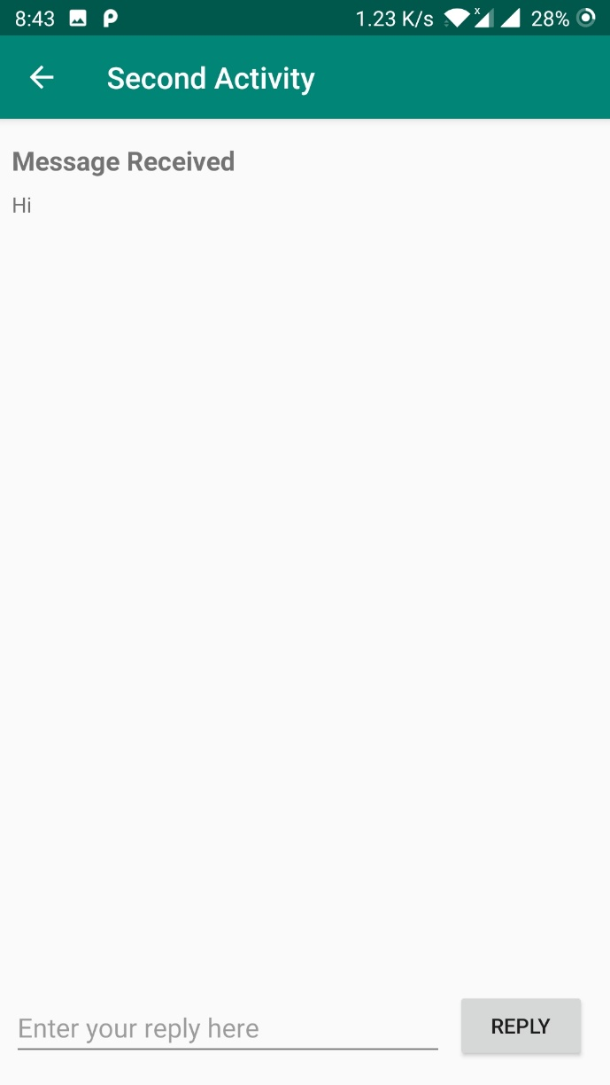 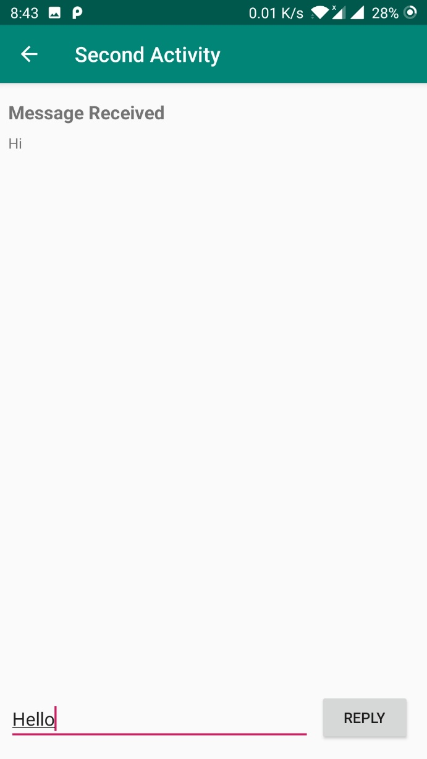

The clicking of reply button result into send the hello message from second activity to again in the main activity

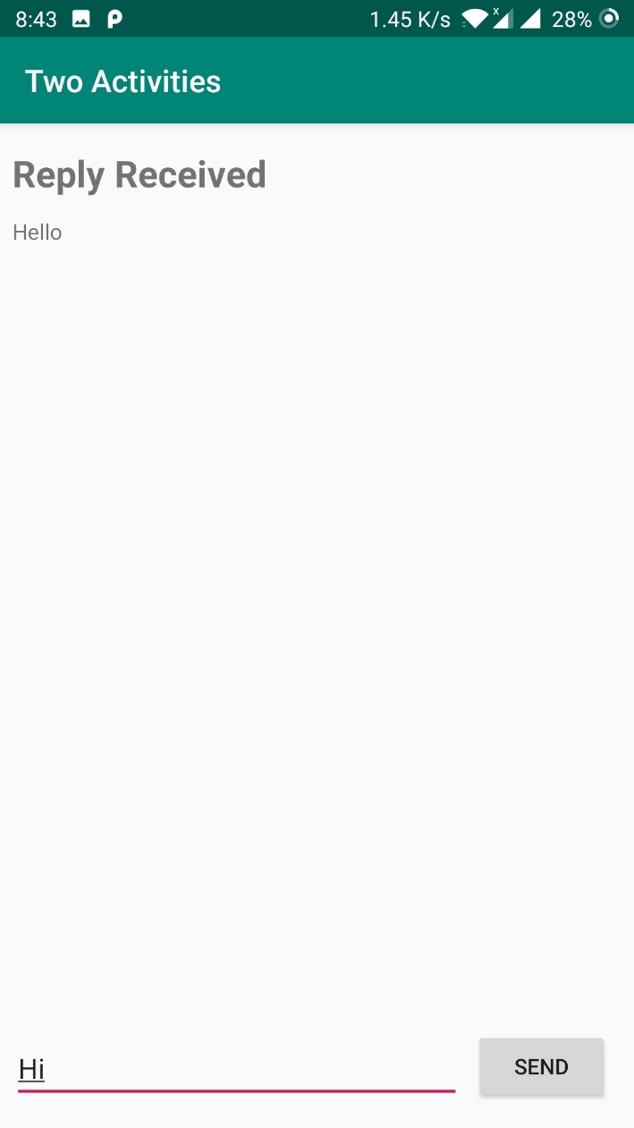

Activity lifecycle and state

On same application there are few additions of codes

Main Activity

|  |
| --- |
| **protected void** onCreate(Bundle savedInstanceState) {  **super**.onCreate(savedInstanceState);  setContentView(R.layout.***activity_main***);  Log.*d*(***LOG_TAG***, **"-------"**);  Log.*d*(***LOG_TAG***, **"onCreate"**);  **mMessageEditText** = findViewById(R.id.***editText_main***);  **mReplyHeadTextView** = findViewById(R.id.***text_header_reply***);  **mReplyTextView** = findViewById(R.id.***text_message_reply***);  **if** (savedInstanceState != **null**) {  **boolean** isVisible = savedInstanceState.getBoolean(**"reply_visible"**);  **if** (isVisible) {  **mReplyHeadTextView**.setVisibility(View.***VISIBLE***);  **mReplyTextView**.setText(savedInstanceState.getString(**"reply_text"**));  **mReplyTextView**.setVisibility(View.***VISIBLE***);  }   }  }   @Override **protected void** onPause() {  **super**.onPause();  Log.*d*(***LOG_TAG***, **"onPause"**); }  @Override **protected void** onRestart() {  **super**.onRestart();  Log.*d*(***LOG_TAG***, **"onRestart"**); }  @Override **protected void** onResume() {  **super**.onResume();  Log.*d*(***LOG_TAG***, **"onResume"**); }  @Override **protected void** onStop() {  **super**.onStop();  Log.*d*(***LOG_TAG***, **"onStop"**); }  @Override **protected void** onDestroy() {  **super**.onDestroy();  Log.*d*(***LOG_TAG***, **"onDestroy"**); } |

|  |
| --- |
| **public void** returnReply(View view) {  String reply = **mReply**.getText().toString();  Intent replyIntent = **new** Intent();  replyIntent.putExtra(***EXTRA_REPLY***, reply);  setResult(***RESULT_OK***, replyIntent);  Log.*d*(***LOG_TAG***, **"End SecondActivity"**);  finish(); } |

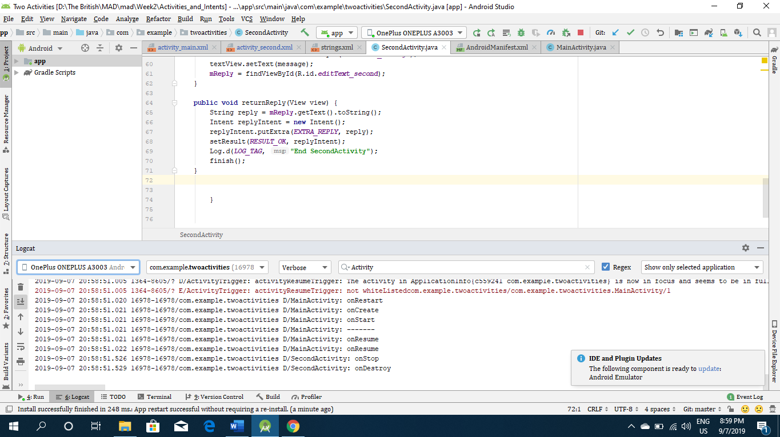

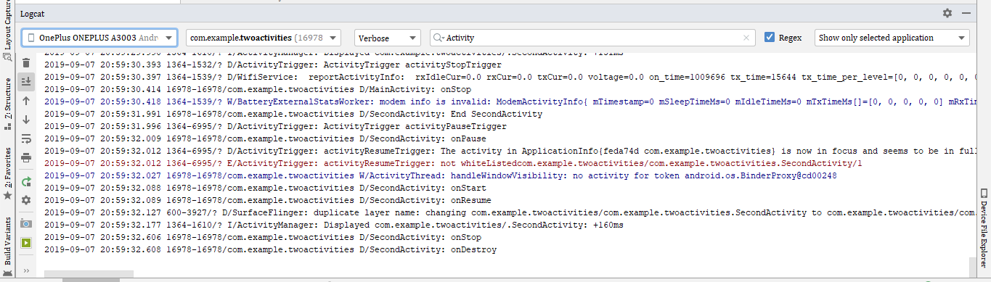

Implicit Intents

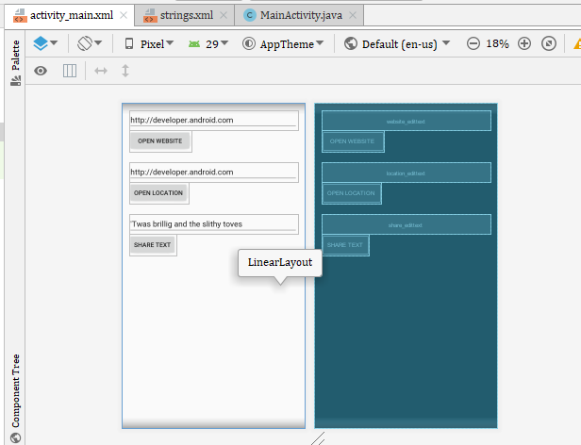

Codes

|  |
| --- |
| *<?***xml version="1.0" encoding="utf-8"***?>* <**LinearLayout xmlns:android="http://schemas.android.com/apk/res/android"  xmlns:app="http://schemas.android.com/apk/res-auto"  xmlns:tools="http://schemas.android.com/tools"  android:layout_width="match_parent"  android:layout_height="match_parent"  android:orientation="vertical"  android:padding="16dp"  tools:context=".MainActivity"**>   <**EditText  android:id="@+id/website_edittext"  android:layout_width="match_parent"  android:layout_height="wrap_content"  android:inputType="textPersonName"  android:text="@string/edittext_uri"** />   <**Button  android:id="@+id/button2"  android:layout_width="140dp"  android:layout_height="wrap_content"  android:layout_marginBottom="24dp"  android:onClick="openwebsite"  android:text="Open Website"** />   <**EditText  android:id="@+id/location_edittext"  android:layout_width="match_parent"  android:layout_height="wrap_content"  android:text="@string/edittext_uri"** />   <**Button  android:id="@+id/open_location_button"  android:layout_width="wrap_content"  android:layout_height="wrap_content"  android:layout_marginBottom="24dp"  android:onClick="openLocation"  android:text="Open Location"** />  <**EditText  android:id="@+id/share_edittext"  android:layout_width="match_parent"  android:layout_height="wrap_content"  android:text="@string/edittext_share"**/>   <**Button  android:id="@+id/share_text_button"  android:layout_width="wrap_content"  android:layout_height="wrap_content"  android:layout_marginBottom="24dp"  android:onClick="shareText"  android:text="Share Text"** />  </**LinearLayout**> |

String.xml

|  |
| --- |
| <**resources**>  <**string name="app_name"**>Implicit Intents</**string**>  <**string name="edittext_uri"**>http://developer.android.com</**string**>  <**string name="button_uri"**>Open Website</**string**>  <**string name="edittext_loc"**>Golden Gate Bridge</**string**>  <**string name="button_loc"**>Open Location</**string**>  <**string name="edittext_share"**>\'Twas brillig and the slithy toves</**string**>  <**string name="button_share"**>Share This Text</**string**> </**resources**> |

MainActivity.Java

|  |
| --- |
| **package** com.example.implicitintents;  **import** androidx.appcompat.app.AppCompatActivity; **import** androidx.core.app.ShareCompat;  **import** android.content.Intent; **import** android.net.Uri; **import** android.os.Bundle; **import** android.util.Log; **import** android.view.View; **import** android.widget.EditText;  **public class** MainActivity **extends** AppCompatActivity {  **private** EditText **mWebsiteEditText**;  **private** EditText **mLocationEditText**;  **private** EditText **mShareTextEditText**;  @Override  **protected void** onCreate(Bundle savedInstanceState) {  **super**.onCreate(savedInstanceState);  setContentView(R.layout.***activity_main***);  **mWebsiteEditText** = findViewById(R.id.***website_edittext***);  **mLocationEditText** = findViewById(R.id.***location_edittext***);  **mShareTextEditText** = findViewById(R.id.***share_edittext***);  }   **public void** openwebsite(View view) {  String url = **mWebsiteEditText**.getText().toString();   *// Parse the URI and create the intent.* Uri webpage = Uri.*parse*(url);  Intent intent = **new** Intent(Intent.***ACTION_VIEW***, webpage);   *// Find an activity to hand the intent and start that activity.* **if** (intent.resolveActivity(getPackageManager()) != **null**) {  startActivity(intent);  } **else** {  Log.*d*(**"ImplicitIntents"**, **"Can't handle this intent!"**);  }  }   **public void** openLocation(View view) {  String loc = **mLocationEditText**.getText().toString();   *// Parse the location and create the intent.* Uri addressUri = Uri.*parse*(**"geo:0,0?q="** + loc);  Intent intent = **new** Intent(Intent.***ACTION_VIEW***, addressUri);   *// Find an activity to handle the intent, and start that activity.* **if** (intent.resolveActivity(getPackageManager()) != **null**) {  startActivity(intent);  } **else** {  Log.*d*(**"ImplicitIntents"**, **"Can't handle this intent!"**);  }  }   **public void** shareText(View view) {  String txt = **mShareTextEditText**.getText().toString();  String mimeType = **"text/plain"**;  ShareCompat.IntentBuilder  .*from*(**this**)  .setType(mimeType)  .setChooserTitle(**"Share this text with: "**)  .setText(txt)  .startChooser();  } } |

